k-s test is the application of hypothesis testing to check whether two dist are same or not,

let’s take an example of two medicines, the first drug claims that it reduce fever in 4hrs, and second drug claims that it reduce fever in significantly less time than drug 1.

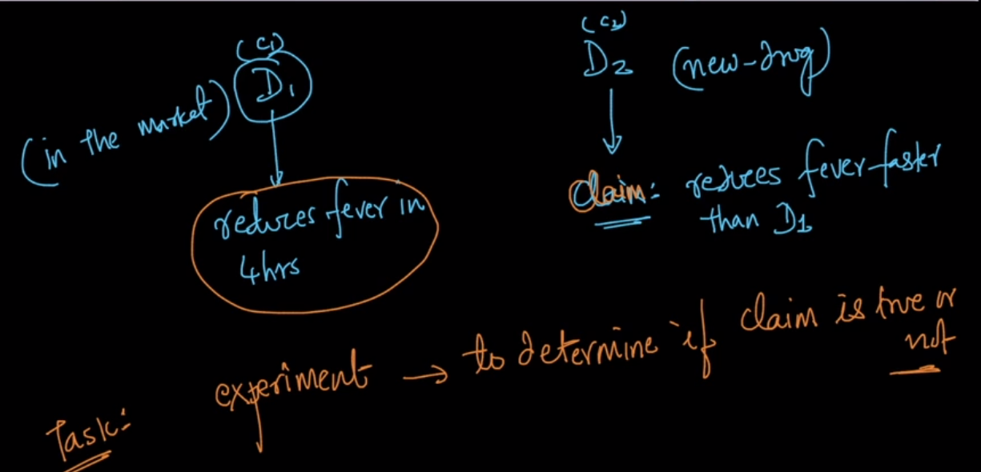

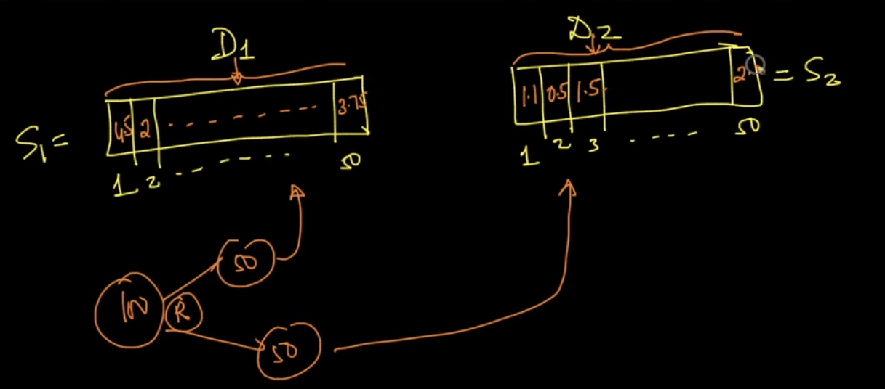

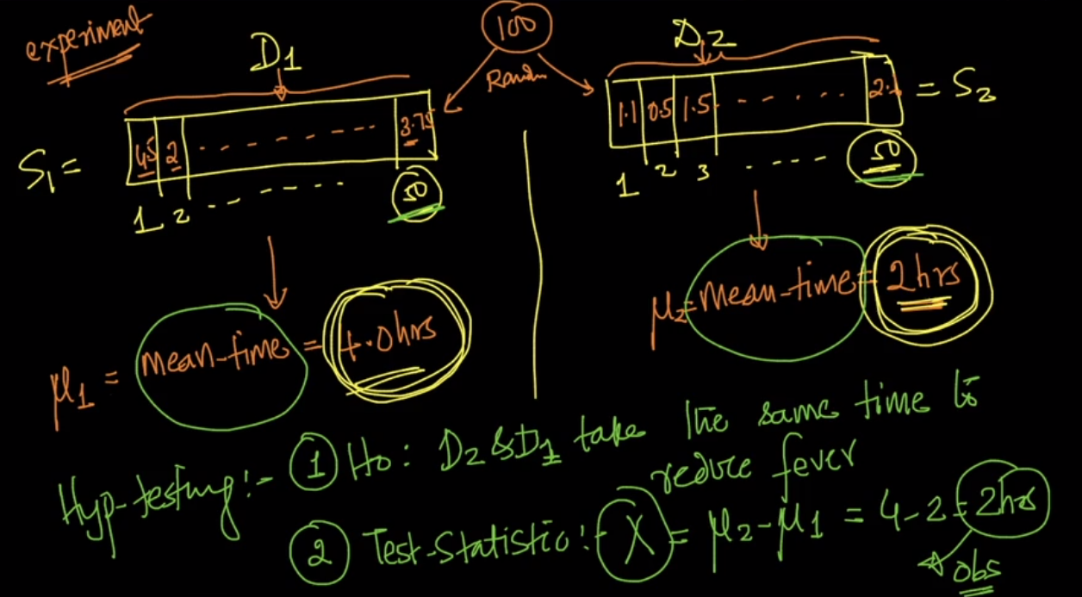

when Probability or p-value is very small then we reject null hypothesis

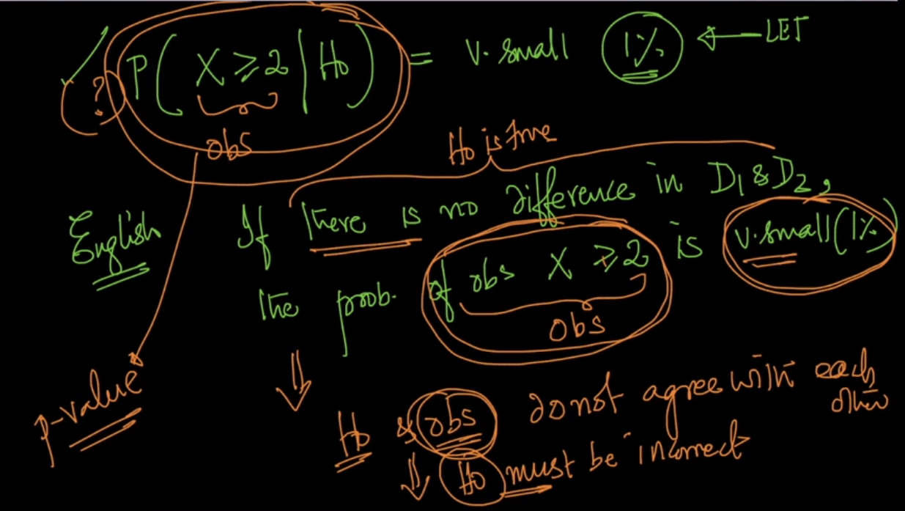

Below image shows which significance level we should choose, for example for medical purpose we want to be very sure that is 99% to accept alternative hypothesis, hence if we get pvalue greater than 1%, then we accept null hypothesis, because getting pvalue greater than 1% means there 100-pvalue% of accuracy in alternative hypothesis.

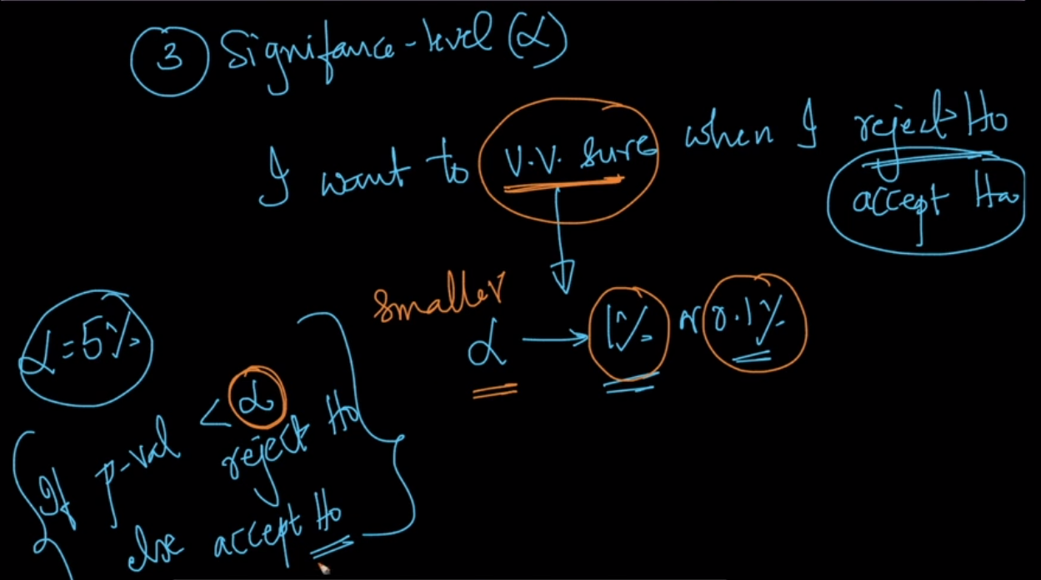

For ecommerce we can take significance level of 3% or 5%.